**Homopolymerization and Copolymerization of Vinyl Chloride over Supported Metalorganic Catalysts**

***Natalia Yu. Ivanova1, Lydmila A. Petrova2***



Semenov Institute of Chemical Physics, Russian Academy of Sciences, Moscow, Russia,

*e-mail: nivanova@bk.ru

1Kurnakov Institute of General and Inorganic Chemistry, Russian Academy of Sciences, Moscow, Russia

Received:, Accepted:, Published:

**Abstract** –The homopolymerization of vinyl chloride and its copolymerization with ethylene over dibutyl ether-modified SiO2-supported Ziegler-Natta catalysts based on titanium and vanadium chlorides have been studied. The supported metal complexes are sufficiently active in the polymerization of vinyl chloride. Their activity depends on the catalyst composition and conditions of formation of the catalyst on the surface of the support.

*Keywords*: polymerization, vinyl chloride, ethylene, polyvinyl chloride, copolymers.

**INTRODUCTION**

Polyvinyl chloride (PVC) is one of the most widely used polymers in the world due to its outstanding mechanical and physical properties. It ranks second after polyolefins in terms of the amount manufactured.

**EXPERIMENTAL**

Vinyl chloride polymerization over the catalysts was conducted in a liquid monomer medium in an autoclave with a volume of 200 cm3 at 20°C.

**RESULTS AND DISCUSSION**

Table 1 presents activity data for the Si–O–VCl3 + AlEt2Cl + DBE + CO catalytic system in the copolymerization of VC and ethylene and molecular weight characteristics of the resulting copolymer.

|  |  |  |  |  |  |  |
| --- | --- | --- | --- | --- | --- | --- |
| Catalytic system | Мn ͯ 10-3 | Mw ͯ 10-3 | Mw/Мn | Мz ͯ 10-3 | Copolymer yield*, kg/gV | Ethylene content,  mol % |
| AlEt2Cl+ДБЭ | 64 | 160 | 2,5 | 267 | 0,27 | 22 |

***Table 1.*** Activity data for the Si–O–VCl3 + AlEt2Cl + DBE + CO catalytic system in the copolymerization of VC and ethylene

*The polymerization time is 24 h.

Figure 1 shows the kinetic curve for vinyl chloride polymerization over catalytic system A. It can be seen in the figure that this catalytic system exhibits the highest activity at the early steps of the process and then undergoes rapid deactivation.

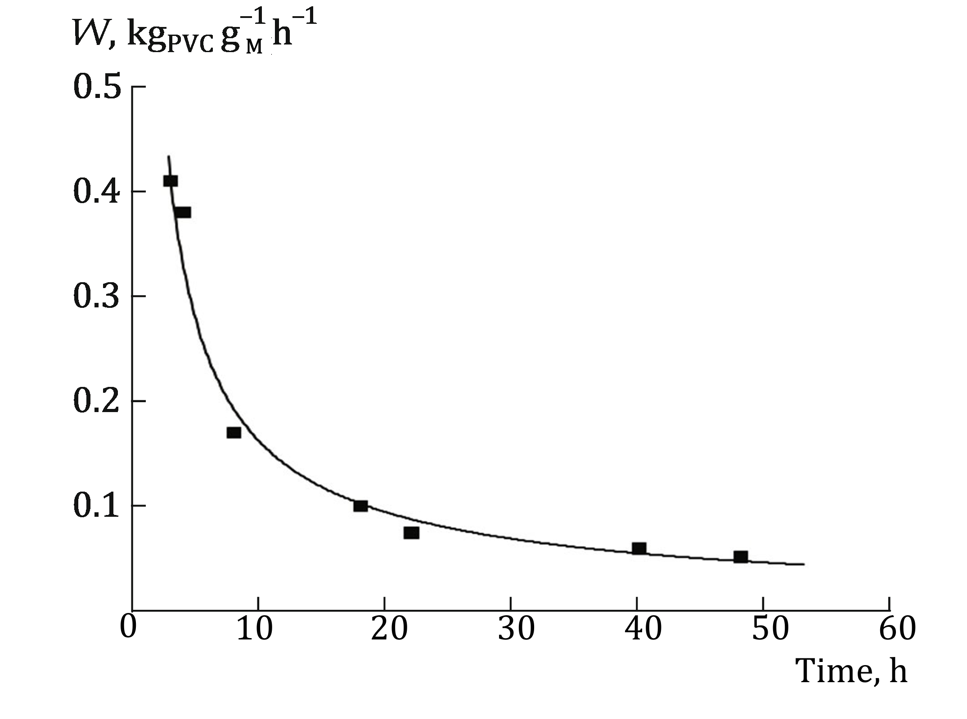

***Fig. 1.*** Kinetics of VC polymerization over catalytic system A.

**CONCLUSIONS**

Therefore, it can be assumed that the radicals resulting from the cleavage of the M–C bond and initiating free-radical VC polymerization, differ from typical free radicals and, apparently, are localized within the transition metal coordination sphere. It can possibly explain the reason why VC polymerization with classical radical initiators differs from the same process involving ionic coordination polymerization catalysts.

*ACKNOWLEDGEMENT*

*The work was supported by the grant of Russian Fund for Basic Research (Project No. 16-03-20280).*

References:

1. Slutskii, V.G., Grishin, M.V., Kharitonov, V.A. Gatin, A.K., Shub, B.R., & Tsyganov, S.A. (2013). Synthesis of Organoboron Nanoparticles. *Russian J. Phys. Chem. B,* ***7***(3), 343–346. <https://doi.org/10.1134/S1990793113030123>.
2. Travin, S.O. & Skurlatov, Yu.I. (2019). Analytical Equation for Breakthrough Curves of Pollutant in the Process of Column Dynamic Adsorption. *Khimicheskaya Bezopasnost’ = Chemical Safety Science, 3*(2), 151–159 (in Russ). <https://doi.org/10.25514/CHS.2019.2.1601001>
3. Davydova, S.L. & Tagasov V.I*.* (2002). *Heavy metals as superecotoxicants of the 21st century*. M.: RUDN. (in Russ.).
4. Roumak, V.S., Umnova, N.V., Belov, D.A., & Lazareno, D.Yu. (2011). *Studies of the links between the levels of PCDD/PCDFs in the environment, in the organisms of rural Vietnamese population and their diagnosable health characteristics.* *In: Environment and human health in dioxin-polluted regions of Vietnam*. M.: Tovarishchestvo nauchnykh izdaniy KMK. (pp. 186–194) (in Russ.).
5. Ganchin, V.V. (2012). Development of project innovation development management methods in electric power industry (Doctoral dissertation). St. Petersburg: St. Petersburg State University. (in Russ.).
6. Tatsyi, Yu.G. (2018). Anthropogenic mercury pollution: necessity for control. *Proceedings of IVth International conference “Actual Scientific & Technical Issues of Chemical Safety”.* M.: IKhF RAN. P. 58 (in Russ). DOI: [10.25514/CHS.2018.10.5577](https://doi.org/10.25514/CHS.2018.10.5577)
7. Pat. 176066, Russian Federation, 2017.
8. Fundamentals of the State Policy in the Field of Ensuring Chemical and Biological Safety of the Russian Federation for the Period up to 2015 and beyond. Approved by the Order of the President of the Russian Federation on 01.11.2013, No. Pr-2573 (in Russ.)
9. On Ratification of the Stockholm Convention on Persistent Organic Pollutants. Federal Law of the Russian Federation of June 27, 2011, No. 164-FL (in Russ.)
10. GOST (State Standard) 8677-76. Reagents. Calcium oxide. Technical conditions [in Russian].
11. Hygienic Standard 2.1.7.3298-15 “Approximate permissible concentrations of polychlorinated dibenzo-p-dioxins and dibenzofurans (equivalent to 2,3,7,8-tetrachlorodibenzopara-dioxin and its analogues) in the soil of populated areas, agricultural lands and industrial site”. September 15, 2015. <http://docs.cntd.ru/document/420306463#loginform> (accessed 9.10.2018) (in Russ.).
12. Stockholm Convention on Persistent Organic Pollutants. http://chm.pops.int/TheConvention/Overview/TextoftheConvention/tabid/2232/Default.aspx (accessed 07.02.2020).